lernOS Guide
Digital Collaboration
A guide for small groups to learn and practice digital collaboration in an organizational context.
Britta Müller-Ruhnau, Daniel Prial, Fabienne Theis,
Magnus Rode, Rainer Bartl, Stefanie Ammler
Version 2.0 (September 2025)

lernOS Guide – Digital Collaboration
Version 2.0 (February 2025)
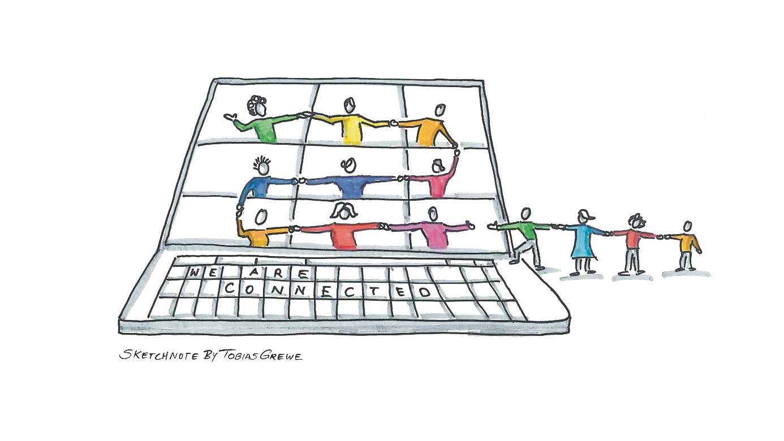
Britta Müller-Ruhnau, Daniel Prial, Fabienne Theis, Magnus Rode, Rainer Bartl, Stefanie Ammler

Table of contents
Welcome 4
Introduction to digital collaboration 4
Why digital collaboration? 5
What are digital collaboration tools? 5
What does digital collaboration involve? 6
About lernOS 8
Learning path 9
Your learning journey at a glance 9
Preparatory meeting - getting to know each other and organizing the Circle 11
Kata 1 - How do we work together in the Circle? 13
Kata 2 - Communication: Analysis and reflection 15
Kata 3 - Communication: Get to know your tools 16
Kata 4 - Communication: Choose the right communication channel 18
Kata 5 - Pit stop: Circle-Retro 20
Kata 6 - Organizing meetings efficiently 23
Kata 7 - Making decisions 25
Kata 8 - Working together on documents 26
Kata 9 - Find knowledge 28
Kata 10 - Valuing knowledge 30
Kata 11 - Sharing knowledge 32
Kata 12 - Sprint-Review 35
Conclusion 37
Fundamentals (Theory) 38
Theory: Basics of cooperation 38
Theory: Communication 43
Theory: Retrospective 51
Theory: organizing meetings efficiently 53
Theory: Making decisions 54
Theory: Know - Find - Appreciate - Share 59
Appendix 68
Templates 68
Making of and acknowledgements 69
Contact us 69

Welcome

Introduction to digital collaboration
The "Digital collaboration" learning guide is designed for all who ...
- ... work together in a digital context (company, organization, association, ...)
- ... have realized that digital work consists of more than e-mail and office programs
- ... who are open to digital collaboration and want to learn more about it
- ... who would like a little more orientation in the digital world
- ... who already have some experience with collaborative tools - and newbies are also very welcome!
Getting started with digital collaboration is very individual. There is no one perfect way. Everyone has a different approach. We, the authors, asked ourselves how we started in our own Digital Collaboration journey. Here are a few thoughts:
"Then came corona ... and everyone suddenly wanted to work digitally. During this time, I took part in many webinars to gather more ideas and get to know new tools, such as Mural, Miro etc., in order to bring them into the company and make digital collaboration a tangible experience."
"At the end of 2019, my team leader moved to Tokyo for a few weeks, so we also needed to try out and learn about digital collaboration in my team. We successfully introduced MS Teams to the team and still use it today to exchange information on specialist topics and organizational matters."
"Achieving a lot with small things: Using MS Teams instead of emails, sharing documents in SharePoint for collaboration, building in Forms surveys, etc. (mindset change)."
"I'm glad I discovered our networking tool back then and have been actively using it to share knowledge with colleagues from other areas of the Group ever since. The information from Yammer has brought me many benefits in my daily work."
This way, everyone sets off on the path and keeps learning. If you do the learning path with a group, you all have the advantage of learning from and with each other at the same time. Each of you has a different goal, a different motivation. What you all have in common is that you all want to learn. And that's what matters.
This learning guide isn't a step-by-step guide on how to collaborate digitally. Instead, think of it as an accompaniment to your own learning journey. The important thing is to try out new things, find your own use cases and test them in a protected space before you introduce it in your team, department, etc.
Our guide is all about (digital) collaboration with others. That's why we've put the theory section, which anyone can work through on their own, at the end so that you can get straight into action with your Circle.

Why digital collaboration?
The world in which we live and work is constantly changing. This requires new competencies and skills, but also different ways of working in order to meet the current challenges (e.g. digital transformation, VUCA¹⁾ world, mobile office, remote work, new work, etc.). This also gives rise to new concepts of collaboration that must and may be embraced
¹⁾ VUCA stands for volatility, uncertainty, complexity and ambiguity.
This is exactly where the guide for digital collaboration comes in. In addition to the tools, the focus is on methods and strategies for digital collaboration, networking and knowledge dissemination.
Many of the formats and methods that appear in this guide also exist in the analog world. This guide shows possibilities for implementing them in a digital context. These can also be used both synchronously (at the same time) and asynchronously (with a time delay). In this context, we speak of collaboration tools that are used.
In the following graphic, you can see the different levels various scenarios for digital collaboration for different audiences:
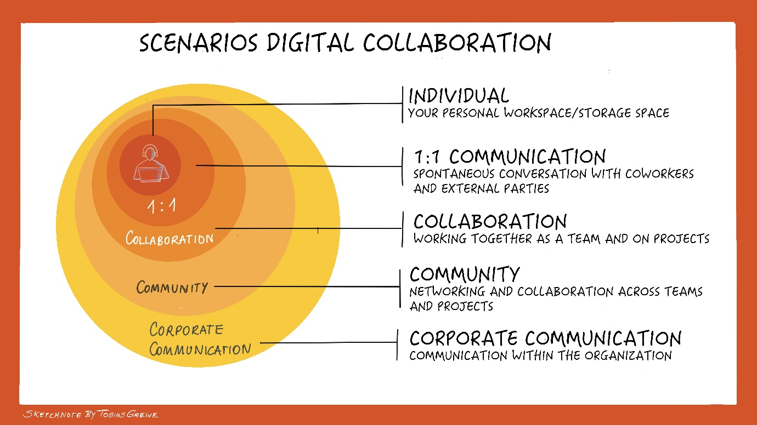

What are digital collaboration tools?
The digital collaboration of teams is made possible by digital collaboration tools. This allows teams of people from inside and outside the organization to come together to work on projects and topics.
Digital collaboration tools are applications that enable digital collaboration within the team, department and/or company. They also promote internal communication. Well-known examples include: MS Teams, Slack, Planner, Asana and Mural.
Notes on dealing with shadow IT:
- In this guide, we provide examples of tools. You will need to check with your organization and, if necessary, use them in a company-compliant manner.
- The same applies to companies that adapt this guide to your system. They are responsible here for clearly saying which tools are allowed and which are not.

What does digital collaboration involve?
Digital collaboration includes the following aspects, among others:
- Communication (chat, video calls, Employee Social Networks)
- Sharing knowledge
- Working together on documents
- Retrospective
- Relationship work
- Making decisions
- Planning
- Brainstorming
And that isn’t an exhaustive list. In this guide, we focus on the aspects highlighted in bold.
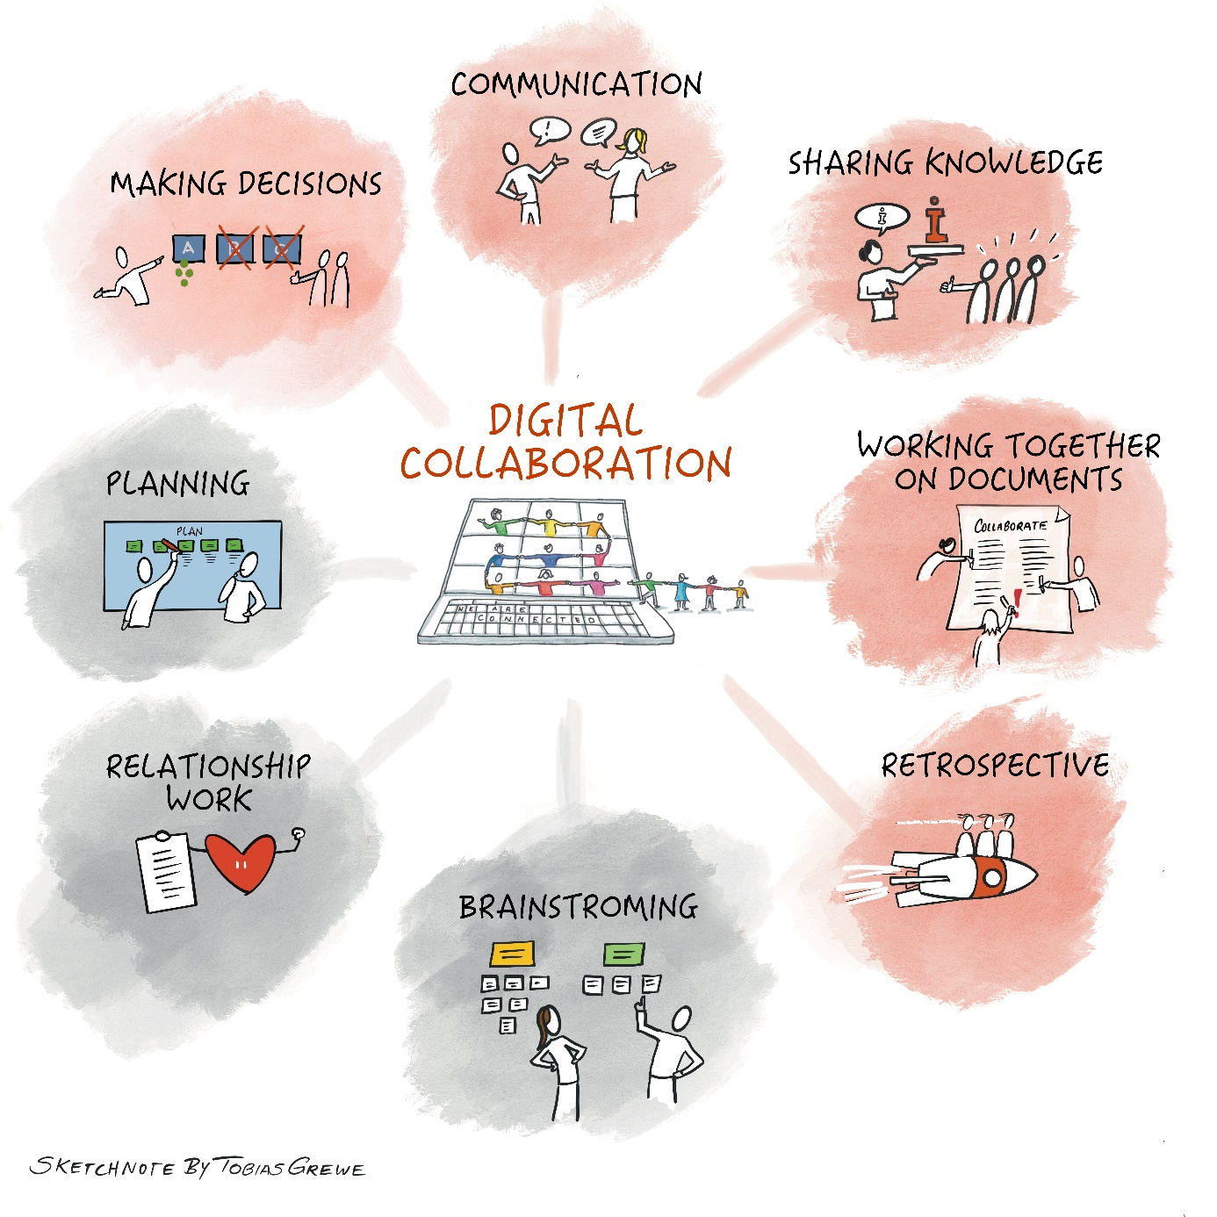

Once you have worked through the Learning Guide,
- you will understand how you and your team/work group can achieve your goals effectively and smoothly through digital collaboration,
- you will know various tools, methods and strategies for working together digitally, and
- you will have the foundation to work well together across all contexts and platforms.
This digital collaboration guide covers a lot of topics that are not always easy to present in an abbreviated form. So have the courage to just get started. Start your own personal learning journey.

About lernOS
lernOS is an open system for lifelong learning and learning organizations. The functionality of lernOS is described in openly available guides. lernOS can be practiced easily as an individual, in a team, or throughout an entire organization.
If you are starting as an individual, we recommend starting together in a Circle (4-5 people) or at least in a learning tandem (2 people). You can find more information on the lernos.org website. You can easily find fellow learners in the lernOS Community CONNECT.
lernOS guides are licensed under Creative Commons Attribution 4.0 International (CC BY 4.0):


You may:
- Share - reproduce and redistribute the material in any format or medium.
- Edit - combine, change and build on the material for any purpose, even commercially.
Under the following conditions:
- Attribution - You must give appropriate credit, include a link to the license, and indicate if changes have been made. This information may be provided in any reasonable manner, but not in such a way as to give the impression that the licensor is endorsing you or your use in particular.
- No further restrictions - You may not use any additional clauses or technical procedures that legally prohibit others from doing anything that the license permits.
Advice for the individuals in a company who want to adapt this learning guide to their company culture:
We recommend that individuals in companies (e.g., multiplier networks) adapt this lernOS guide for themselves in order to integrate examples and tools from their own company.
In order to reduce the barriers to entry, adapt the guide to the local IT landscape within the company. Make sure to include the collaboration methods your company uses and include stories appropriate to your experiences.
The guide can of course also be used in parallel by several Circles in the company (Learning Circle Experience). Provide the Circles with templates and a structure to work in.
Note for individuals who want to use the learning guide with others:
We recommend using this guide in a group, as the focus is on the topic of collaboration with other people. Cross-company circles are possible, but the "translation" to the tool level must be done by the participants themselves.
If you would like to find out more about lernOS [all resources in German]:
- Video "lernOS- an introduction to lernOS, the open system for lifelong learning and learning organizations" by Simon Dückert
- Further information on the lernOS website
- If you would like to initiate a Circle yourself and are looking for peers, you can do this via the Peerfinder app.
- You can find the lernOS community here.

Learning path

Your learning journey at a glance
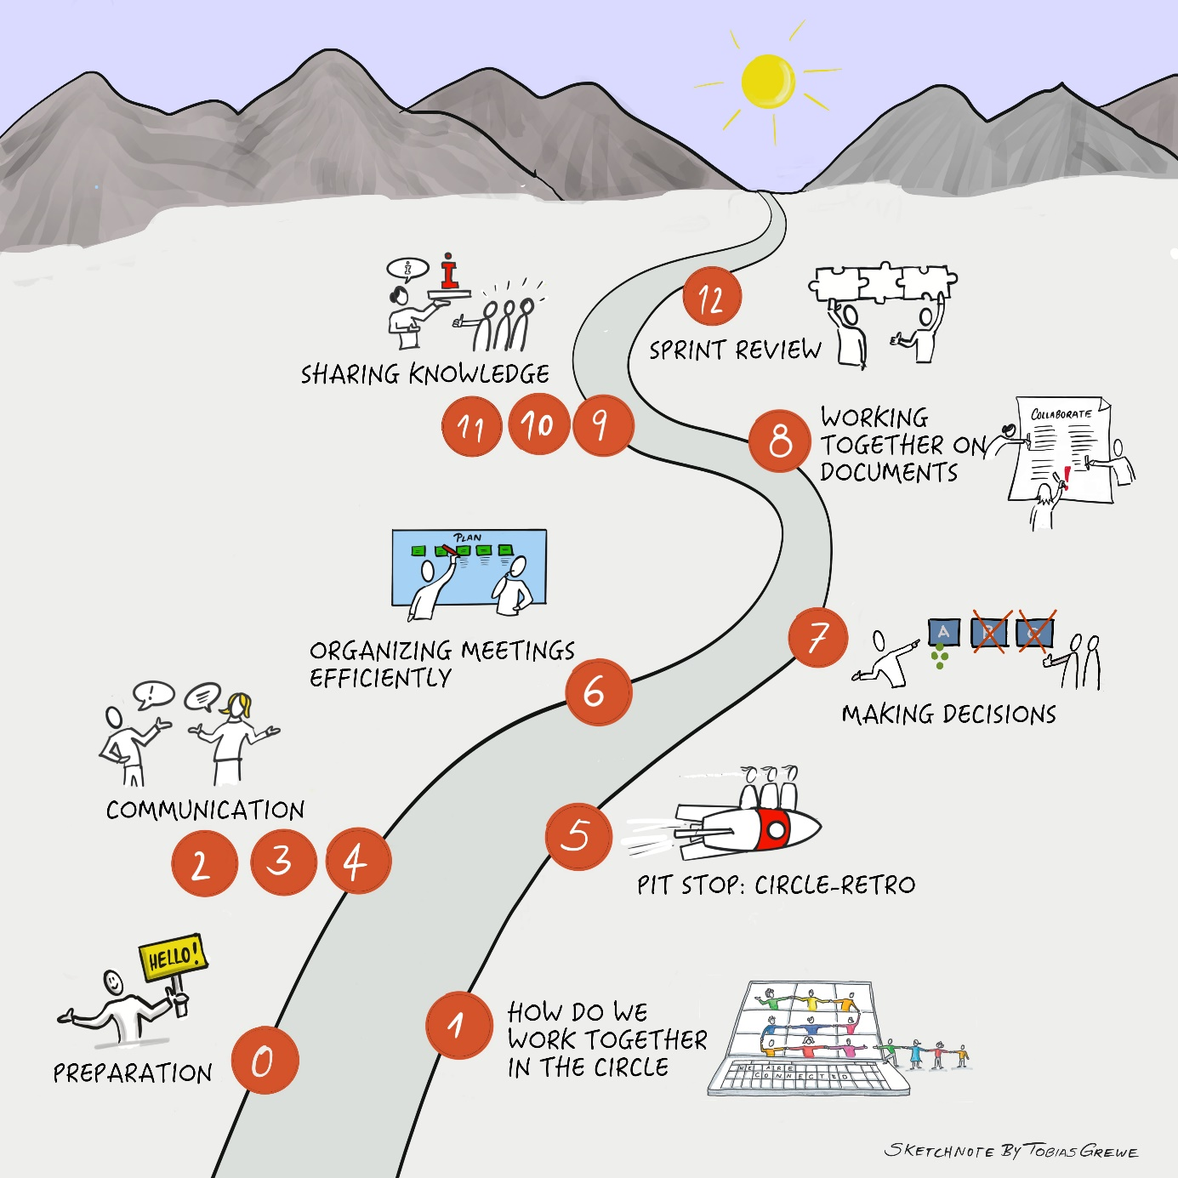
This guide is divided into 12 Katas (exercises). We recommend working on these in joint meetings or gatherings. The simplest way to work through the learning journey would be over the course of 12 weeks with one Kata and one meeting per week. Of course, the 12 Katas can also be used freely however you like if this time frame does not fit.

The diagram shows the recommended order of the learning journey. Of course, the order of the topics can also be chosen freely.
- The preparation meeting (Step 0) is about preparing the learning journey, being clear about your own motivation and agreeing with the learning group how you want to organize yourselves during this time.
- In the first Kata, we introduce you to the Collaboration Canvas and lay the foundation for your collaboration in your circle.
- Katas 2-4 deal with various aspects of the topic of communication. You will learn about suitable tools and channels for communication and find out how to optimize your communication.
- In Kata 5, you make a pit stop by performing a circle retrospective.
- In Kata 6, you will receive suggestions on how to organize meetings efficiently.
- The theme of Kata 7 is "Making decisions" and how this can be done digitally.
- In Kata 8, the focus is on working together on documents. You will learn what needs to be considered in digital collaboration.
- In Katas 9-11, the focus is on sharing knowledge. You deal with the aspects of "finding information", "valuing information" and "sharing information".
- A sprint review awaits you in Kata 12. This is where you reflect on your learning journey.

Brief guide to planning your trip
Each step on the learning journey requires
- Preparation (individual work)
And then a meeting (in the Circle / Group work) with the following agenda:
- Check-in
- Main topic
- Check-out
You prepare an exercise (what we’re calling Kata) before the group meeting so that you can discuss it together in the circle/working group.
Scheduling
Please allow at least 2 hours per session: 1 hour (or more) for your Kata and 1 hour for the subsequent group meeting. Preparation and follow-up times may vary.
Digital collaboration is a very wide-ranging topic. Not all aspects can be covered equally. Your level of knowledge will also vary in the individual areas.
Please determine your focus and decide for each Kata whether you want to do more in addition to the learning path - there are further tips and tasks for you in each Kata.

And now: have fun on your journey!

Preparatory meeting - getting to know each other and organizing the Circle

Here we go!
Your lernOS Digital Collaboration journey starts today. The preparation meeting is an opportunity for you and your group to come together, get to know each other and make some basic logistical arrangements for how you will spend your time together. We recommend a 12-week learning sprint - and the guide is designed that way - but you should be guided by the needs of your group and decide what works best for you. If necessary, you can extend your meetings or decide together what your rhythm should be.
It's okay if the decisions you make today are not perfect. We will guide you and help you to rethink your decisions and adjust them if necessary.

Preparation (individual work)
There is nothing to prepare for this meeting.

Agenda (circle/group work)
- Check-in: (25 minutes)
Welcome!
Nice to have you here!
Introduction: Each Circle member introduces themselves in 5 minutes.
- Please think for a moment, why are you here?
- Take the time to write down your personal reasons and share these and other information about yourself with your Circle.

Have fun getting to know each other!

- Main topic: (20 minutes)
Plan when you will meet, which tools you would like to use for your collaboration and the meetings and who will take over facilitation (see Kata below)

- Check-out: (5 minutes)
Please confirm the next meeting. What will you do before the next meeting?

Kata "Getting to know each other and organizing the Circle"
This first Kata is about organizing yourselves as a circle.
- Circle moderation and timekeeping: Who facilitates your meetings? Who keeps an eye on the time?
Suggestion: share the facilitation and timekeeping roles so that everyone gets a turn!
facilitation includes:
- Welcome/introduction
- keeping an eye on time and topic
- capturing discussions
- asking for commitments, e.g. for the next week
- agreeing to (or confirming) the next date/topic/Kata

- Day and time of the meeting: When do you meet? Who sets the dates? (e.g. 12x Fridays, 10 a.m.)
- Commitment and punctuality: Your learning success depends on you - i.e. keep the appointments and be punctual. Please plan extra time for the weekly preparations so that you are ready to discuss the main topic at the next meeting and can share your experiences and insights. This will show appreciation for your Circle.
- Tools: What do you want to use for your communication, your meetings and for your documentation?
Clarify whether all Circle participants have these tools and can use them.
To be able to work together digitally in the lernOS Circle itself, it is necessary to agree on a suitable Circle setup.
After all, we want to apply everything we learn ourselves as soon as possible and thus understand and internalize it.

The following points need to be clarified:
- Common communication platform (e.g. MS Teams, Slack, possibly Messenger for fast communication)
- Video conferencing solution for meetings (e.g. MS Teams, Zoom)
- Shared document storage (e.g. MS Teams documents, SharePoint)
- Shared documentation (e.g. OneNote, Padlet, Word document)
Store notes and homework in OneNote or Word in a shared location
à see also theory “Working together on documents”

If you want to do more:
Create a list of all the channels you use so that you can then create a shared list in the Circle.

Kata 1 - How do we work together in the Circle?

Your entry into digital collaboration
In the preparatory meeting, you have already started discussing your collaboration with your learning group. In this Kata, we present a structure for all digital collaborations: the Collaboration Canvas. The Collaboration Canvas is a framework for building group agreements and collaboration. Think of your learning circle as a collaboration group - how will you work together? ...communicate with each other? ...make decisions? ...share your knowledge? At the end of this learning journey, you will be able to use these tools with all your other working groups.

Preparation (individual work)
- Read the Kata "How do we work together?", do the exercises.
Tip: You will always find the task text for the Kata after the agenda

Agenda (circle/group work)
- Check-in: (10 minutes)
What has been on your mind this past week in relation to digital collaboration?
Two-minute timebox per Circle member.
- Main topic: (45 minutes)
- Present your results and findings from Kata 1 - How do we work together? (below) to each other and discuss them
- Develop your rules for collaboration in the Collaboration Canvas.
- Write your conclusions from week 0 in the canvas.
- During the following weeks of the circle, consider whether rules in the canvas should be adapted or expanded. After each week / journey stage, take the time to fill it out step by step.

- Check-out: (5 minutes)
What will you do before the next meeting?

Kata "How do we work together?"
- To prepare, read through the content in the chapter Basics: Collaboration.

- Take a look at the Collaboration Canvas (see below). The canvas offers you the opportunity to record the new impulses and recommendations you have learned for implementation in your daily working life while working with the guidelines. Some topics (e.g. sharing documents) will be addressed in more detail during the course of the Circle.

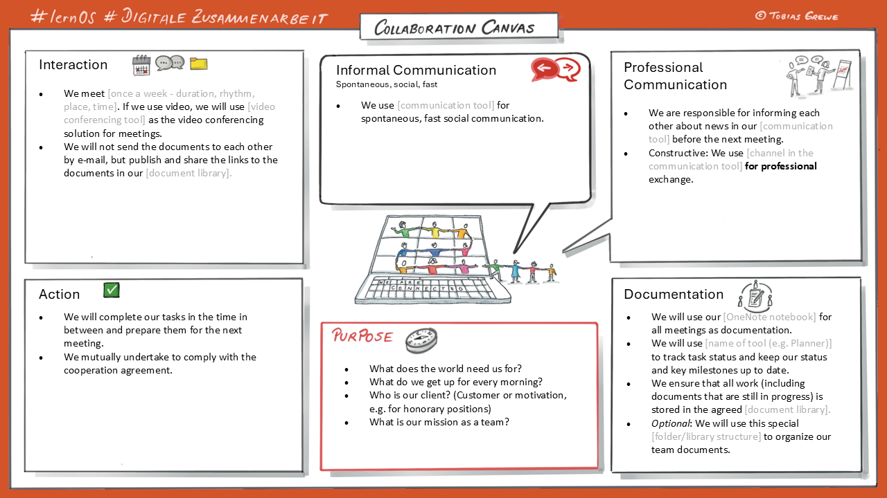
Collaboration Canvas

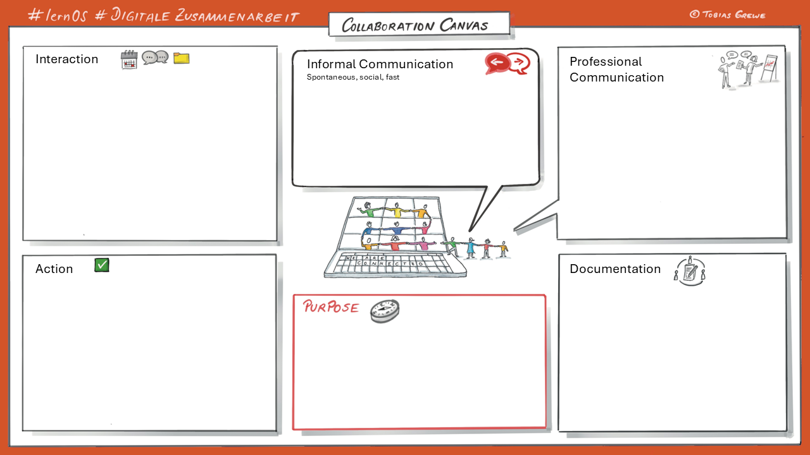
- Think about which cooperation agreements you already have. Which ones are important to you and why? Make a note of them.

If you want to do more:
- Further information can be found here: Rules for cooperation.

- As a suggestion - take these rules of collaboration as an opportunity to develop your own collaboration canvas with your team.
After a month, you can conduct a retro with your team and share your experiences.

Kata 2 - Communication: Analysis and reflection
The next 3 Katas deal with the topic of communication. By definition, collaboration takes place between different people. Communication is the way we connect with the people around us and exchange information. Communication and collaboration are fundamentally linked – and strong communication is a prerequisite for effective collaboration.
Here it is particularly important to avoid frustration and stress by optimizing your communication. It is also helpful to select the appropriate channels/tools to enable fast and effective collaboration with internal and external parties. All with the aim of optimizing your handling of incoming communication.
In this Kata, we start by analyzing and reflecting on your communication.

Preparation (individual work)
- Read the Kata "Analyze and reflect on your communication" (see below) and do the exercises.
Tip: You will always find the task text for the Kata after the agenda.

Agenda (circle/group work)
- Check-in: (10 minutes)
What has been on your mind this past week in relation to digital collaboration?
Two-minute timebox per Circle member.
- Main topic: (45 minutes)
Present your results and findings from Kata 2 - Analyze and reflect on your communication (below) to each other and share them.
- Check-out: (5 minutes)
What will you do before the next meeting?

Kata "Analyze and reflect on your communication!"
- To prepare, read through the basics in the "Cooperation" theory:
  - Synchronous vs. asynchronous communication
  - Push vs. pull communication

- Which communication channels do you already use, which do you know, but don't use?

- Look through your communication channels!
  - Which communication works well / which creates stress?
  - Which message/information arrives where?
  - When/how do you need the information?
  - Can you find the information quickly/easily?
  - What annoys you?
    - e.g. invitation to meeting without agenda, CC mail to all
  - What are your needs?
  - Check your expectations: What helps you? What can you change?

Tip: Be careful not to do the things that annoy you when communicating with others.

If you want to do more:
- Create a list of all the channels you use so that you can then create a shared list in the Circle.

Kata 3 - Communication: Get to know your tools
This week you will learn about suitable tools for communication.
Humans have almost unlimited communication options. And there are always more possibilities than we are aware of. For example, have you ever tried not speaking for a day? Or have you ever been to a country where you couldn't speak the language? You still manage somehow, don't you? Studies suggest that our non-verbal communication outweighs our verbal communication by a factor of 3 or 4 to 1.
When we communicate and collaborate digitally, we need to think carefully about what tools are available to us and what advantages and disadvantages they have.
How do your tools work and how do they help you communicate your message most clearly?

Preparation (individual work)
- Read the Kata "Get to know your tools" (see below) and do the exercises.
Tip: You will always find the task text for the Kata after the agenda.

Agenda (circle/group work)
- Check-in: (10 minutes)
What has been on your mind this past week in relation to digital collaboration?
Two-minute timebox per Circle member.
- Main topic: (45 minutes)
Present your results and findings from Kata 3 - Get to know your tools (below) and share them with each other
- Check-out: (5 minutes)
What will you do before the next meeting?

Kata "Get to know your tools!"
Communication tools offer many settings options and functions to make your daily work easier.

- Select your preferred communication tools and think about how you have been using them so far.
Do you use the tool for push or pull communication? Is it a tool officially managed by IT? Which functions of the tool excite you? Do you find interesting functions that you have not yet used? (see evergreen approach)

- Take a look at the following programs and points, for example:
E-mail (example Outlook, Thunderbird):
- File" or "Start" menu area: e.g. save templates
- Extras" menu area: e.g. set up rules or set automatic responses

Chat (example MS Teams, Slack):
- Define notification options: e.g. when do I want to be informed about new messages and how?
- Edit messages (edit mode)
- Use @mentions
- Use emojis in a targeted manner (e.g. thumbs up = read confirmation, heart = like)
- Status: e.g. what does "busy" / "do not disturb" mean? How is the status interpreted by colleagues?

Online meetings (e.g. MS Teams, Zoom):
- Share/present screen options
- Raise your hand & use emojis
- Set up and use breakout rooms
- ...

- What new functions have you found?
- Which functions will you use in the future and how?
- Collect functions that inspire you and that you would like to pass on to your Circle as a tip.

If you want to do more:
- Look on the Internet and search for further instructions for the tools you are using.

- Take a look at other tools that you have not been using so actively so far but would like to use more often.

Note for companies that adapt the guide for themselves:
Here you are welcome to link guides to your tools (and, if you have one, to communities in your ESN = Employee Social Network) where tips, tricks and questions are shared.

Kata 4 - Communication: Choose the right communication channel
In the previous exercises, you reflected on your communication. In this Kata, you will work on how you can improve your communication. You will learn how to select suitable communication channels to enable fast and effective collaboration with internal and external parties.
The focus is on choosing the communication tool that best conveys your message. Some tools are better because they are fast. Other tools are better because they carry emotional undertones. Part of good communication is choosing a good communication medium.

Preparation (individual work)
- Read the Kata "Choose the right communication channel" (see below), do the exercises.

Agenda (circle/group work)
- Check-in: (10 minutes)
What has been on your mind this past week in relation to digital collaboration?
Two-minute timebox per Circle member.
- Main topic: (45 minutes)
Present your results and findings from Kata 4 - Choose a suitable channel (below) to each other and discuss them.
Consider together whether rules for communication in the canvas should be adapted or expanded and, if necessary, expand the collaboration canvas with your new findings.
- Check-out: (5 minutes)
What will you do before the next meeting?

Kata "Choose the right communication channel!"

In the following, you will find out how you can best reach your goals with the help of communication.

- Take another look at the two inputs from Kata 3:
- Info block "Synchronous and asynchronous communication"
- Info block Pull vs. push
- As a basis for the task, take a look at the various subject areas that will help you to select a suitable communication channel.
- Subject area: E-mail
- Subject area: Chat
- Subject area: Meetings
- Subject area: Tasks

- In the next step, answer the following questions using an example topic:

- What do I want to achieve? (goal)
  - Create understanding for a topic?
  - Assign a task?
  - Pass on information? / Status update
  - Discuss a topic?
  - Reach a decision?
  - Should the information be available and retrievable in the long term?
Are there perhaps requirements for archiving / revision security for documentation purposes (e.g. for orders)?
  - Convey a lot of information (that could be lost in a phone call, for example)?
  - Detailed information that requires preparation?
- How quickly and urgently do I need an answer? (urgency)
- Who is my communication aimed at? (target group)
  - Individual / Group?
  - Do I know the right contact person?
  - Who is the target group?
- Is it an emotional or unemotional topic? (Emotions)
  - Caution: Emotional topics are difficult to place and control without direct eye contact!
  - Public visibility is not always useful: criticism, for example, is sometimes better placed in person.

- How much time and effort do I need to prepare / does my counterpart need to answer?
  - How complex is the topic? (Complexity)
  - Is there a great need for explanation?
    - Tip: Save information in a document or presentation (meeting).
- "Does it have to be a meeting if everyone listens to one person speak?"
(For more information, see Theory: Organizing meetings efficiently).

If you want to do more:
- In theory sections, take a look at the overview "Which tool do I use for what?" and add further suggestions that you can discuss together in the Circle.

- You can also find further material here:
- Communication square: https://en.wikipedia.org/wiki/Four-sides_model
- Driver: https://insightandcoaching.com/2020/02/what-are-your-drivers-take-the-online-test/

Kata 5 - Pit stop: Circle-Retro
Take a look back together as a circle, as a group.
Retrospectives are an opportunity to learn from our experiences and improve. They help us to reflect on what went well, what went wrong and what we can do differently.
In this Kata you will explore why retrospectives are important, how you could conduct them and what benefits they have for you and your teams.
Then do a retrospective on your collaboration at a Circle up to this point.
How did it go? What do you want to leave out? What would you like more of?

Preparation (individual work)
- Read "Kata 5 - Retrospective" (see below), do the exercises.

Agenda (circle/group work)
- Check-in: (10 minutes)
What has been on your mind this past week in relation to digital collaboration?
Two-minute timebox per Circle member.
- Main topic: (45 minutes)
Present your results and findings from the Kata 5 Retrospective to each other and discuss them.
Which retro template do you want to use to carry out the Circle pit stop?
(If you can't decide, just try this template: 4L)
Use it to reflect together on how your previous collaboration in the Circle has gone.

- Then, write down your points (e.g. in bullet points on sticky notes), and talk about them. Try to understand each other and - if you have time - find solutions.
- Consider together whether rules in the collaboration canvas should be adapted or expanded,
if necessary, expand the Collaboration Canvas with your new findings and formulate your common rules of collaboration.
- Check-out: (5 minutes)
What will you do before the next meeting?

Kata - Retrospective
In this Kata you will get to know the possibilities of retrospective experience exchange. You will get an overview first and try out a retrospective together in your circle, your group, in the next session.

You can use the retrospective format (retro for short) in the future: in project groups or to evaluate joint processes or events, for example. Retrospectives are used in the agile approach.

- Take a look at the various tools and templates and discuss them with your Circle at the next meeting. If you have already heard of retro, you can go straight to the exercise part, but if you would like to find out more about what a retro is and what retrospective means, then take a look at the "Retrospective" theory.

- Example of a retro:
4L method:
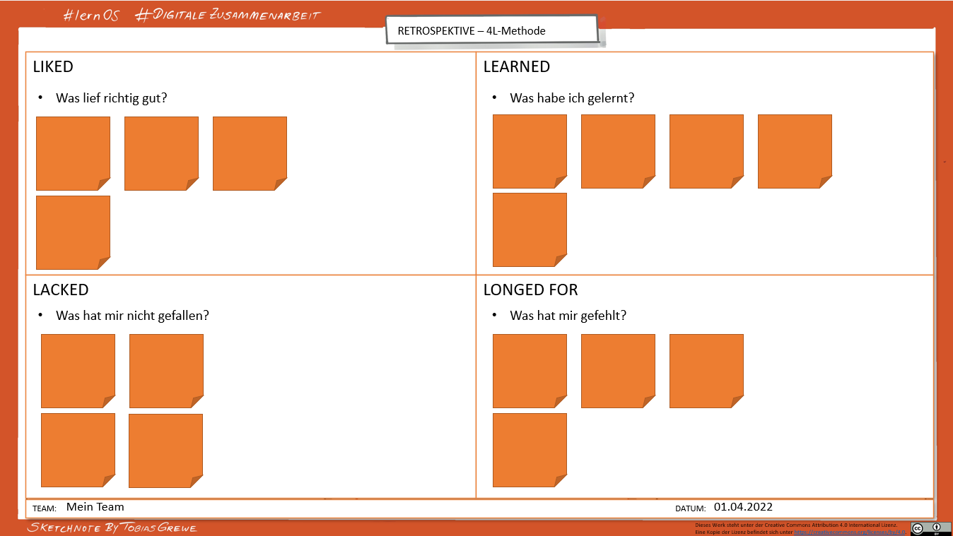

You can find a PowerPoint template for this under Templates.
- Use templates or templates:
  - Mural https://www.mural.co/templates/retrospective
  - Miro https://miro.com/templates/retrospective-tool/ and https://miro.com/templates/4-ls-retrospective/
  - Trello https://trello.com/b/hkaQsLWx/sprint-retrospectives

- Further material:
  - https://retromat.org/de/ [GERMAN]
  - https://retromat.org/blog/best-retrospective-for-beginners/
  - https://www.liberatingstructures.com/7-15-solutions/
- Instructions:
  - Retrospective https://www.atlassian.com/team-playbook/plays/retrospective
  - 4L retrospective https://www.atlassian.com/team-playbook/plays/4-ls-retrospective-technique
  - Starfish method https://t2informatik.de/wissen-kompakt/starfish-retrospektive/ [GERMAN]

- Examples:
  - https://www.collaboard.app/en/blog/retrospective-online-whiteboard
  - https://agilescrumgroup.de/retrospektive-formen-mit-beispielen-und-ideen/ [GERMAN]

Choose one of the templates explored above and make a Circle pit stop based on this retrospective. Reflect together with your Circle on how your collaboration has gone so far, what you definitely want to keep and what you want to leave out. Think about this now so that you can get started promptly at the next meeting.

If you want to do more:

- If you have already tried the retro within the learning journey, the next step could be to try it out with your own team or another group.

Kata 6 - Organizing meetings efficiently
"This meeting could have been an email!"
Meetings can be powerful tools for collaboration, but they often become boring, uninteresting or, in the worst case, pointless. This Kata is about how to make meetings more efficient and more effective.

Preparation (individual work)
- Read the Kata "Organizing meetings efficiently" (see below), do the exercises.
Tip: You can find the complete text of the Kata after the agenda.

Agenda (circle/group work)
- Check-in: (10 minutes)
What has been on your mind this past week in relation to digital collaboration?
Two-minute timebox per Circle member.
- Main topic: (45 minutes)
Present your results and findings from Kata 6 – Organizing meetings efficiently to each other and discuss them.
- Check-out: (5 minutes)
What will you do before the next meeting?

Kata "Organizing meetings efficiently"

- Read through the basics in preparation:
Organize meetings efficiently

- As a review, take another look at the theory under Communication - Topic area: Meetings.

- In Kata 4 - Choose a suitable channel, we asked you:
"Does it have to be a meeting when everyone listens to one person speak?"
Pick a meeting from the calendar from the last few weeks that you hosted and answer the following questions:
- How was the agenda for the meeting created?
- Were minutes / documentation of the most important findings create during the meeting? If so, how? and where are they now?
- Was it clear to all participants after the meeting what tasks had been defined?
- How could you have organized your meeting more efficiently?
- What points could you have clarified without this meeting?
- What information could have been shared with everyone beforehand?

Plan your next meeting taking into account the knowledge gained and experiences made so far. Share how it went in the next circle meeting.

If you want to do more:

- If you are planning a meeting with your team, create a shared document / OneNote page / wiki page for the meeting where you plan the topics to be discussed together before the meeting and use it to put together an agenda.
- For each item, consider whether it needs to be discussed "live" (synchronously) or whether it can be clarified (at least in part) in advance (asynchronously).
Tip: Whoever has placed an item on the agenda is also responsible as the topic owner, as is responsible for
  - providing materials / documents for reading ahead of time, and
  - moderating the agenda item during the meeting

Kata 7 - Making decisions
In every collaboration, decisions must be made together. The choice of approach or method has a major influence on whether the decision is made quickly and purposefully or whether the team gets bogged down in endless discussions without reaching a common consensus.

Preparation (individual work)
- Read the Kata "Making a decision" (below) and do the exercises.

Agenda (circle/group work)
- Check-in: (10 minutes)
What has been on your mind this past week in relation to digital collaboration?
Two-minute timebox per Circle member.
- Main topic: (45 minutes)
Present your results and findings from "Kata 7 - Making a decision" (below) to each other and discuss them.
- Check-out: (5 minutes)
What will you do before the next meeting?

Kata "Making decisions"

- Read the theory
- How does decision-making take place digitally in your team, your workplace (if you don't meet in person)?
- What is going well?
- What is not going so well?
- What methods/tools do you use for this?

- Think about how you ask the question. (Theory: Types of questions)
- Find a suitable tool for your question and try it out in the Circle
Choose a tool/method from Theory: Tools to make a decision on your question. Take another look at Kata 4 - Choose a suitable channel.

If you want to do more

- Familiarize yourself with other tools and methods and think about where you could use them.

- Research further methods for decision-making and try them out in the next meetings of your Circle or in your team.

- Reflect on the result in the relevant group to see whether this method has helped you come to a decision.

Kata 8 - Working together on documents
In this Kata, which is based on our rules for collaboration, you take another step further by not only sharing documents with others, but by also developing them together. You and your group will create a concrete example of this: a collection of "the best hacks for digital collaboration".

Preparation (individual work)
- Read the Kata "Working together on documents", (below) do the exercises.

Agenda (circle/group work)
- Check-in: (10 minutes)
What has been on your mind this past week in relation to digital collaboration?
Two-minute timebox per Circle member.
- Main topic: (45 minutes)
Present your results and findings from "Kata 8 - Working together on documents" to each other and discuss them.

Use your shared collection of "the best hacks for digital collaboration" in the Circle meeting and think about a common structure. How did the asynchronous collaboration go?
Consider together whether rules in the canvas should be adapted or expanded,
if necessary, expand the Collaboration Canvas with your new findings and formulate your common rules of collaboration.
- Check-out: (5 minutes)
What will you do before the next meeting?

Kata "Working together on documents"

- Read through the basics in preparation. Working together on documents

- Answer and reflect on the following questions:
- Where is your collaboration canvas stored?
- How did you work here?
- How did the collaboration work?
- Have you seen the changes made by the others?
- How did it feel that everyone immediately saw what you had written?
- Did it save time for the exchange?
- Should the document be available and retrievable in the long term? What do you need to do?

- As group, create a file in your shared digital workplace which you can work on asynchronously.

- Individually, create contributions for the shared collection in this shared file.
- Think about how you could work together asynchronously on documents in Circle and which tool you can use for this. In How do I share documents in a chat? (example M365) you can find inspiration for this

If you want to do more:

- Continue to work together asynchronously:
- You can add to the list in the next few weeks if you think of more hacks.
- You can add comments to other people's hacks, e.g. if you particularly like something or if something is unclear.
- Can you see who has added which points / track changes?
- You can share the hacks with your network.

Kata 9 - Find knowledge
Learning journey through knowledge management
In the next three Katas, we embark on a joint learning journey through levels of knowledge management (see section "Knowledge management: a learning journey through four maturity levels" in the theory section). Our focus here is primarily on the first three levels:
- Finding existing knowledge
- Valuing shared knowledge
- Share your own knowledge
These exercises will help you to improve your skills in dealing with knowledge and accompany you step by step on your path to becoming an active knowledge giver. And every journey begins with a first, small step.
Welcome on board for your knowledge journey!
In this Kata, we focus on finding existing knowledge. It is the first and most important step in expanding your knowledge base. You will learn how to efficiently use search engines, databases or discussion forums to find relevant knowledge.
Start by consciously looking for information that can help you in your work. It can be helpful to look through internal resources such as manuals or knowledge databases.
The aim of this Kata is to recognize that the knowledge you are looking for is often already available - you just have to find the right sources.

Preparation (individual work)
- Read Kata 9 "Finding knowledge", (below) do the exercises.

Agenda (circle/group work)
- Check-in: (10 minutes)
What has been on your mind this past week in relation to digital collaboration?
Two-minute timebox per Circle member.
- Main topic: (45 minutes)
Present your results and findings from Kata 9 "Finding knowledge: How can you benefit from the knowledge of others?" (below) and discuss them.
- Check-out: (5 minutes)
What will you do before the next meeting?

Kata "Finding knowledge: How can you benefit from the knowledge of others?"

- To get started in this area, take a look at the basics of knowledge management.
- Under Knowledge - Formats you will find different ideas on how others have shared their knowledge:
  - Find examples of where and how information and knowledge is shared in your company.
  - Are there any other formats that you know from your private life?
  - Write down all the formats and types you know.
- How could you share your knowledge with other formats in your work environment so that others can benefit from it? Write down all the types and formats that are available to you in your work environment - even if you can't implement each of them right now (e.g. create a post in your Viva Engage community).

- Get specific:
- How and where have you found your knowledge so far?
- Who shared the knowledge?
- How was the knowledge shared (type, format)?
- What did you notice?
- Exchange information within your Circle about where you find your knowledge, who shares it and whether you use different sources.

- Search for specific forums/communities on your topics within your company and show your interest by actively joining them. A small first step is often enough. Have the courage.

If you want to do more :

- If you haven't found anything on a topic yet, why not post a question on the topic in forums/communities?
- Were you satisfied with the content you found? Evaluate for yourself which sources are valuable to you.

Kata 10 - Valuing knowledge
In the last Kata, you looked at how you can find existing knowledge. Now we are going one step further: expressing appreciation for the knowledge you have found. This Kata is all about interaction and exchange with the knowledge givers. Your goal is to become an active part of the knowledge community.
Why is this appreciation so important?
If you find the information you are looking for and can use it to do your job better and/or faster, it is important to show gratitude and give feedback to the person (or team) who shared the knowledge. Anyone who has shared their knowledge is happy to receive this appreciation.
By liking you can show your appreciation for the knowledge you have found, and by commenting or participating in discussions you can give the knowledge providers valuable feedback on how the shared knowledge supports you in your work. This makes you visible in the dialog.
These interactions are valuable for everyone involved because they not only give feedback to the knowledge givers, but also help you to delve deeper into the subject matter and gain new perspectives.

Preparation (individual work)
- Read the Kata "Valuing knowledge" (below) and do the exercises.

Agenda (circle/group work)
- Check-in: (10 minutes)
What has been on your mind this past week in relation to digital collaboration?
Two-minute timebox per Circle member.
- Main topic: (45 minutes)
Present your results and findings from Kata 10 - "Valuing knowledge" (below) to each other and discuss them.
- Check-out: (5 minutes)
What will you do before the next meeting?

Kata "Valuing knowledge"
- Now let's go one step further and change our perspective:
- When was the last time that you were really grateful because a colleague shared something with you and you benefited from their knowledge?
- How are you showing gratitude so far? Think of other ways you can show that the knowledge you have shared has helped you.
- What experiences have you had with it? How did it feel for you?
- What differences do you perceive between business and private interactions?
You will find suggestions in the theory
- Think about what other ways there are to enter into an exchange (interaction)?

- Find an appropriate forum and answer a question that has been asked there, or comment on knowledge that has already been shared.

If you want to do more:

- Try out other forms of gratitude in your work environment that you have just learned and actively show your appreciation - and be curious to see how this kind of "feedback" makes an impact.
- Gratitude appointment: Set up a regular meeting appointment (e.g. before the weekend) and think about how you have benefited from the knowledge of others in the past week or how colleagues have supported you in your work. Show your gratitude - in your own way.

- Report back to your team and pass on your experiences from this exercise.

- Take a look at the LernOS Learning Path Openness & Networking [GERMAN]. (Overview - lernOS for you guide (cogneon.github.io))

Kata 11 - Sharing knowledge
After learning to find and appreciate the knowledge shared by others in the last two Katas, it’s time to become active yourself and share your own knowledge with others.
The aim of this Kata is to gain the courage and take the first steps to share your knowledge with others. The exercises will help you to develop further on your knowledge journey and contribute more to your organization's knowledge management step by step.
"Sharing is caring!" That sounds good - but this step can seem very challenging at first and sounds like a lot of effort. Nevertheless, it is the decisive milestone in moving from passive consumer to active knowledge provider.
Don't worry - you don't have to publish entire scientific papers - smaller contributions such as tips and tricks, answers to questions in forums or comments on existing articles are just as valuable. Remember: Your knowledge can help others and bring you recognition and visibility in the community.
Good luck!

Preparation (individual work)
- Read the Kata "Sharing knowledge" (below) and do the exercises.

Agenda (circle/group work)
- Check-in: (10 minutes)
What has been on your mind this past week in relation to digital collaboration?
Two-minute timebox per Circle member.
- Main topic: (45 minutes)
Present your results and findings from Kata 11 - "Sharing knowledge" (below) to each other and discuss them.
- Check-out: (5 minutes)
What will you do before the next meeting?

Kata "Sharing knowledge"
- If you are not yet sure whether sharing your knowledge is really worthwhile for you, then take a look at the following arguments:
- Sharing deepens your knowledge
When you explain your knowledge, you understand it better yourself. This process consolidates your knowledge and can give you new insights.
- Sharing gives you valuable feedback
By sharing your knowledge, you get feedback and new ideas from others. This helps you to expand and improve your knowledge.
- Sharing creates satisfaction
It feels good to help others. Sharing your knowledge gives you a sense of fulfillment and satisfaction - especially when others also value your knowledge.
- Sharing strengthens your network
Sharing knowledge builds relationships. People value you as a source of knowledge, which strengthens your personal network.
- Sharing promotes your personal and professional development
By sharing, you become visible with your knowledge and position yourself as an expert. This creates new learning opportunities and helps you to grow and develop further.
- "Sharing knowledge" - it's not that difficult.
A very simple example: If you use Microsoft Office products, you can create a link
in most applications with the shortcut Ctrl+K. This works in Outlook as well as in OneNote or Word, i.e. you can always use this shortcut - it's simply faster. This work hack can be shared quickly and easily in the next team meeting.
Now think about your topic:
- What added value does this knowledge have for your colleagues?
- How can you share your knowledge on a particular topic with others?
- What is stopping you from doing this right now? (important!)

- Be specific and choose a topic that you are an expert in or that particularly interests you:
- How and where have you shared your knowledge with others (type, format)?
- What is your favorite topic that interests you, that you have learned something about, that you have expertise in?
- What topics do you want to be visible with?
- Write these topics on a list - preferably in a personal notebook (book or OneNote).

- And now go one step further and actively share your knowledge on a topic in which you are an expert.
You are welcome to do this in your professional working environment.
- How did that feel? What did it trigger in you?
- What happened? What were the reactions?

If you want to do more:
Not sure what you could share yet?
We've collected a few suggestions here:
- Share your experiences and lessons learned:
Reflect on your way of working. What have you learned - both from mistakes and successes - and what could be useful for others? It could be resources that have helped you, techniques that have moved you forward or mistakes that others should avoid. Remember to package it as a post that offers your insights to others in a way that is helpful to them.
Example: Holger Moller, Learning Journey Miro: https://holgermoller.wordpress.com/2021/02/15/learning-journey-miro/ [GERMAN]
- Think about which formats are best for you to share your knowledge: Under Knowledge - Formats you will find different ways in which others have shared their knowledge.
- Openly ask for feedback on the tasks/content you are working on:
It creates added value for you and others if you openly discuss what you are currently working on.
- Share your experiences and insights with your own colleagues and consider together:
What can you do specifically to ensure that knowledge is shared in the team, in the community, etc.? e.g. introduce the agenda item "Work hack - what great things did I learn this week?" at every team meeting.
- You are also welcome to use the shared collection of "Digital collaboration hacks" from the Kata "Working together on documents" as inspiration to pass on your knowledge.
- Examples of knowledge transfer methods ( Cogneon )
- Barcamp
- Community of Practice
- Expert Debriefing (Cogneon-Wiki [GERMAN]: https://wiki.cogneon.de/Expert_Debriefing)
- Knowledge café
- Massive Open Online Course
- Podcast
- Screencast
- Webinar
- Working Out Loud
Source: Cogneon-Wiki: Knowledge transfer [GERMAN]: https://wiki.cogneon.de/Wissenstransfer

Kata 12 - Sprint-Review
You have almost reached your goal with your circle. This is the last Kata of the learning path. You talk about your self-reflection on the learning process. If you want, you can also do another retro. You will remember this from Kata 5.

Preparation (individual work)
- Read the Kata "Sprint-Review", (below) do the exercises.

Agenda (circle/group work)
- Check-in: (10 minutes)
What has been on your mind this past week in relation to digital collaboration?
Two-minute timebox per Circle member.
- Main topic: (45 minutes)
Present your results and findings from the "Kata 12 - Sprint Review" (below) to each other and discuss them.
If there is still time left and you want to, you can also do another retro [Kata 5 - Retrospective].
In any case, also discuss how you want to proceed with the jointly created and/or shared documents.
Take another look at your Collaboration Canvas. Have you stuck to your common rules of collaboration? Which rules make sense? What would you add?
Take the Collaboration Canvas to your other teams and groups.
- Celebrate: (as long as you like) celebrate your learning success!
Either today or you can arrange a separate appointment.

- Check-out: (5 minutes)
How do you part?
Do you possibly want to meet up again to keep in touch? Perhaps at different intervals?

It's great that you've stuck with it this far and continued to build up your digital collaboration expertise. Click here for the conclusion.

Kata "Sprint-Review"
- Collect your experiences and lessons learned in another joint document in the Circle.
You have set off on your journey. How far have you come and what's next for you?
Have you discovered the joy of digital collaboration? What are you planning to do next?
It's time to reflect on the learning experiences behind you and at the same time look at how you can move forward with the topic.
Take another look at the lernOS canvas you created at the beginning and answer the following questions:
- What was your starting situation?
- What have you learned?
  - in general with regard to digital collaboration
  - in relation to "Communication
  - in relation to "sharing knowledge"
  - with regard to "Working together on documents"
- What has helped you the most?
- What were you most surprised about?
- What's next for you? Which aspect would you like to deepen? What would you like to learn more about?

If you want to do more:
- Great! You have completed the guide for "digital collaboration".
By the way, there are more lernOS guides on many exciting topics.

Conclusion
Wow, you've made it! You have now worked intensively on the topic of "digital collaboration" in the guide and have reached the end of the learning path. Congratulations!
Do you remember the graphic at the beginning of your learning journey? You set out on your journey and stuck with it. It's worth sticking with it: the successes become visible - for you and others.
What’s next? Some circles have grown into real learning groups and continue to meet regularly, perhaps at longer intervals (e.g. every 2 or 4 weeks instead of weekly). Certain topics from the learning path can be worked on again in greater depth or Katas can be repeated. Discuss with your circle how you can share your learning progress in the future and advise each other as colleagues by introducing new application ideas from your own fields of work.
Keep calm and learn on!

Fundamentals (Theory)

Theory: Basics of cooperation

Collaboration Canvas (also: collaboration canvas)
Canvas

We have prepared a collaboration canvas in PowerPoint that you can use to record your rules for collaboration.

You can also use the following image as a background for other tools:


As an alternative to the canvas, you can use the following text as a template/idea/suggestion in a tool of your choice:
Rules for our cooperation in the lernOS Circle:
Goal: Our lernOS Circle has the following common goal [formulate goal]
We lay down the following rules for cooperation within the team:
Purpose / Goal
- What does the world need us for?
- What do we get up for every morning?
- Who is our client? (Customer or motivation, e.g. for honorary positions)
- What is our mission as a team?
Interaction
- We meet [once a week - duration, rhythm, place, time]. If we use video, we will use [video conferencing tool] as the video conferencing solution for meetings.
- We will not send the documents to each other by e-mail, but publish and share the links to the documents in our [document library].
Action
- We will complete our tasks in the time in between and prepare them for the next meeting.
- We mutually undertake to comply with the cooperation agreement.
Communication, informal (spontaneous, social, fast)
- In a nutshell: We use [communication tool] for spontaneous, fast social communication.
Communication, technical
- We are responsible for informing each other about news in our [communication tool] before the next meeting.
- Constructive: We use [channel in the communication tool] for professional exchange.
Documentation
- We will use our [OneNote notebook] for all meetings as documentation.
- We will use [name of tool (e.g. Planner)] to track task status and keep our status and key milestones up to date.
- We ensure that all work (including documents that are still in progress) is stored in the agreed [document library].
- Optional: We will use this special [folder/library structure] to organize our team documents.

Further links to rules for cooperation
Basics:
- Microsoft: The Social Collaboration Contract

Deepening:
- Atlassian - Playbook - Working at Atlassian
- Atlassian - Playbook - Working Agreements in action
- Office Kaizen: Rules of the game [GERMAN]
- Expert study: Microsoft Teams: marketing hype or game changer? [GERMAN]

Idea for developing the rules for teamwork:
Working agreements | Atlassian

"Working together on documents"
Sharing documents in the cloud (example Microsoft365)
- Tip: Work on a document together at the same time
If you want to work together on content in a document, you often had to laboriously consolidate corrections and contributions from individual people piece by piece into one document. As soon as documents are stored in the cloud (e.g. on SharePoint, TeamSites or in OneDrive), it is possible for several people to work on a document at the same time (via sharing via link (see tip 4)). Link to further information & instructions.

- Tip: Use automatic versioning in cloud storage
By storing documents in the Microsoft Cloud, work statuses are automatically saved, and versions of a document are kept track of. If you work on documents together, this function gives everyone the security that documents and work statuses cannot be accidentally deleted/moved and thus lost.
Link to further information & instructions.

- Tip: Track changes
In addition to automatic versioning, Word, Excel and PowerPoint documents offer the option of tracking changes. This allows everyone to see which content was edited when and by whom. Change tracking can be easily switched on and off in the main menu item "Review".
Link to further information & instructions.

- Tip: Use the comment function in the document
In Word, Excel and PowerPoint, you can leave specific comments, e.g. on text passages. Everyone who uses the document can read the comments and reply to them. This allows questions, information and answers to the content in a document to be exchanged quickly and easily. Link to further information & instructions.
- Tip: Share files via link
It is advisable to always store files in the cloud storage first (e.g. TeamSite or personal OneDrive) and then share the file via a link in the team channel, a 1:1 chat or group chat. This way, the file remains in the selected storage location. If you simply share a file via drag & drop in a chat, it is automatically stored in the channel folder (Teams Chat) or in the OneDrive of one of the chat group participants. This creates a copy of the original file.

How do I share documents in a chat? (Example M365)
Chat communication is very important for collaboration in a group. There are several options for this in Microsoft Teams: you can use the channels in a team in MS Teams - or create a group chat in the personal chat area. Meeting chats are also often used for group communication. The options are useful for different use cases but differ in important details if you also want to share documents via chat.
Teams channel | Group chat | Meeting chat
Advantages:  Shared files are automatically stored on the TeamSite in the corresponding channel folder.  All team members (including external persons/guests) automatically have access to files that are shared via the TeamSite and/or directly in the channel. (is also removed again when leaving the team!) | Advantages:  When a new person is added to the group chat, you can decide individually whether the history of the chat should be released for viewing in full, in part or not at all. | Advantages:  Well suited for chat communication during and shortly after an appointment.
Disadvantages:  No direct integration of persons outside the M365 group possible. | Disadvantages:  Non-transparent file storage  Even if all files appear to be organized in the Files tab of the chat, there is no shared file storage. The shared file is stored with the person in OneDrive in the "Microsoft Teams chat files" folder. All files shared by the person in 1:1 chats, group chats and meeting chats using drag & drop are stored there. This storage can therefore quickly become very confusing and take up a lot of storage space.  People who are added to the chat later do not automatically have access to the shared files.  As soon as an external person (= guests in the M365 tenant used) joins the group chat, files can no longer be shared.  Guests cannot access the shared files. | Disadvantages:  Non-transparent file storage  Even if all files appear to be organized in the files tab of the chat: there is no shared file storage (for details see description "Group chat").  External persons (= guests in the M365 tenant used) can only see and access shared files if they have a guest account and have also logged into the meeting via this account.

Tool collection
Various tools for joint text creation [GERMAN]

Theory: Communication

Basics: Synchronous & asynchronous communication
Synchronous communication
- synchronous: at the same time; running at the same speed
- The communication partners enter the communication situation at the same time.
- Examples: direct conversation/meeting, video/audio call
- Advantages: direct and fast exchange
- Disadvantages: Lack of interaction rules or lack of consideration. The technology used must be mastered.
Asynchronous communication
- asynchronous: not synchronous, not simultaneous, not running at the same speed
- The contributions to communication take place at different times.
- Examples: Letter, fax, e-mail, chat
(Note: e-mail and chat are often misused as a synchronous means of communication!)
- Advantages: no immediate reaction necessary. People can decide for themselves when and how to react.
- Disadvantages: Replies may come too late or even be forgotten. Information may be more difficult to find, and the references of messages may be unclear. This can lead to misunderstandings.
Here is an overview of the various combinations:
Matrix | Synchronous | Asynchronous
Personal  (1:1) | Video call  Videocall | e-mail  chat
group  (1:N) | Telephone/audio conference  Video conference | E-mail distribution list  MS Teams channel  Group chat  ESN

Basics: Push vs. pull communication
Push:
Example: E-mail
Features:
- Sender defines recipient
- Sender decides what is important for recipient
- Receiver is passive
- Closed communication to individuals or a targeted group of people
- Recipient is extrinsically motivated
Pull:
Example: Chat in teams, post in ESN (Enterprise Social Network = social network in the company)
Features:
- Sender publishes information
- Recipient decides what is important to him or her
- Recipient is active
- Open communication to everyone in the company or a group or team
- Recipient is intrinsically motivated

Subject area: E-mail
Incoming e-mail communication
Classify your emails and messages:
- Complete (five-minute rule)
- Schedule/define task
- Forwarding/delegating
- Archive
- Delete
Do not reply to e-mails immediately but set time frames for replies.
Turn off email notifications in your Outlook settings if they distract you.

Outgoing e-mail communication
Tips for e-mail communication
- Define what it is about in the subject line
- First things first
- Make short statements, send clear messages
- Structuring texts (using formatting, inserting links in the text)
- Give deadlines
- Schedule communication and decision windows
- Avoid CC e-mail. CC emails are not honest and not transparent.
  - Content is often not understandable for all recipients
  - No one in CC feels responsible
  - None of the people in CC are really informed
  - The entire communication is suddenly made public for others who are not in the topic

Tips for handling the sending of files
- only send e-mails with links (no attachments!)
- Do not use "drag & drop" in email messages, but first save the document to a cloud storage (e.g. files in Teams, OneDrive) and then share the link to it.

Subject area: Chat
Incoming chat communication
- Use the individual notification options in teams (per team / per channel)
- Agree on chat rules with your team (e.g. response times)
- Don't get "infected" by the work behavior of others
- Use @-Mention to make sure you reach people
- Maintain and use e.g. the status display in Teams
- Use the "do not disturb" option consistently for focus work.
Allow certain people "priority access" if necessary
- Use the "Quiet Time" setting in the Teams app on mobile devices
- React to incoming messages: Like, reply or forward

Outgoing chat communication
- #nohello: please don't just write "hello" in the chat, but state your request or question directly
- It's all about fast and uncomplicated communication
- Write as briefly and simply as possible (no long e-mail text)
- Use @-Mention if you want to address someone directly

Tips for chat communication
- Define what it is about in the subject line
- First things first
- Make short statements, send clear messages
- Structuring texts (using formatting, inserting links in the text)
- Give deadlines
- Schedule communication and decision windows

Tips for handling the sending of files
- In chats, only share documents by link (no attachments!)
- Do not use "drag & drop" in chat messages, but first save the document to a cloud storage (e.g. files in Teams, OneDrive) and then share the link to it.

When do I send an e-mail? When do I send a chat message?
E-Mail:
- Information is also relevant for people who are not part of a team or group. (to be checked: it may make sense to open a new chat group for a topic).
- Information has an "official" character
- Information has special compliance requirements (e.g. must
be stored in an audit-proof manner)

Chat:
- Team and group communication (instead of cc e-mails)
- Information should be available to a group for a longer period of time
- Short questions / answers ("Is the image on page xx final? Has the text been approved? Can we postpone the date?")
- Discussions and feedback on a topic ("I need your opinion on..., What points do we need to consider?")
- Chat is faster and more lightweight than email. But keep in mind that the target group is often larger and more open.

Subject area: Meetings
When do I arrange a meeting?
- Do I just want to inform people, or do I also need feedback or a conversation?
- What can be done asynchronously - what should be done synchronously (=together)?
- Caution: Monologues in meetings are an indicator that something could just as well be done asynchronously.
Tips to save time:
- Share PPT/documents with people and ask for specific feedback via chat
- Assign "homework" BEFORE the meeting (e.g. "please read through the presentation beforehand") so that the time in the meeting can be used for discussion.

Tips for organizers:
- Ask yourself: can the topic only be developed in a meeting?
- Send out appointment invitations with target, agenda and tasks
- The roles for the meeting have been clarified.
- Start on time
- Test technical settings before starting the meeting
- After the meeting, everyone knows what happens next.
- Create meeting minutes:
  - What was discussed/decided?
  - Who takes which tasks with them?

Incoming meeting requests
Tips for participants:
- Decline an invitation if you don't know why you should be at a meeting
- Show up on time and prepared for the appointment
- "Multitasking" is rude (and doesn't work). This also applies to online meetings.
- Give feedback (e.g. use the meeting chat / emojis)

Subject area: Tasks
When you assign a task...
- Define what it is about in the subject line (also very useful in team chat)
- First things first
- Make short statements, send clear messages
- Structuring texts (using formatting, inserting links in the text)
- Give deadlines
- Schedule communication and decision windows

When you receive a task...
Tips for prioritization & task planning
- Keep track of tasks + deadlines digitally (maintain digital calendar)
- Check new tasks against your own goals (suppress helper syndrome)
- Don't be taken by surprise: your working hours are limited
- If information is missing: Query time slots for tasks and or define them yourself
- Maintain your to-dos as "equal" appointments
- Plan ahead
  - What do I need so that I can complete my task? For example, do I lack clear deadlines or information?
  - How long do I need for the task?
  - When do I complete this task (incl. fixed date entry)?
  - What do I have to put on hold to complete this task?
  - Signal to others early on if tasks cannot be completed on time.
- Maintain your tasks in ONE place (preferably digital)
  - Use ToDo and Planner, for example, to create task overviews (advantage: direct connection to chat & email)
  - Avoid jumping back and forth
  - Keep the search for information to a minimum

Overview "Which tool do I use for what?"
Think about which tools you have been using for communication and collaboration.
The following overview may help you to reconsider your decisions:

Intention | Traditional proposal | Possible alternative
Voting | Team meeting | Teams post with vote with likes
Passing on information  E.g. Current project status | Meeting | Teams post with linked PPT if necessary
(Technical) question with unknown contact person |  | Post in ESN Viva Engage
Assign task | e-mail | Task in Planner
Instructions / Documentation | E-mail distribution list | Teams-Post / Group-Chat with link to document / wiki page
emotional topic | Phone call | personal conversation  Video call with MS Teams if necessary
Urgent question | Email with priority "Important" | Teams chat/post with "Important" and @mention  if possible with a link to more details
Feedback to individual | Meeting | Chat/video call
Feedback team/group | Meeting | Team channel / video call
Company feedback | e-mail | ESN
...

Evergreen approach
The evergreen approach entails continuous software development, where updates are regularly deployed directly to users. This method contrasts with the traditional practice of releasing infrequent, large updates that encompass numerous changes.

New features and functions can appear every month. It therefore makes sense to regularly engage with your tools in a continuous learning process.
Even if you are very familiar with your tool, there may be new functions that are of interest to you.

Theory: Retrospective

Introduction
Learning from experience is an important aspect of (digital) collaboration. It is about reflecting on what has happened and deriving insights that can be considered in the future to improve collaboration.

Definition of retrospective
As an example, here are two selected definitions of retrospective (or retro for short):

- "Retrospective (from Latin retrospectare, "look back"), generally, is a look back at events that took place, or works that were produced, in the past." (Wikipedia – see section on Software Development)

- "Retrospectives are team meetings that aim to learn from the past. "Retrospective" means "looking back". The team members look back together and evaluate what went well and what went badly. They analyze why things went well or deviated from expectations in order to formulate and tackle measures for improvement. (itit-agile) [ORIGINAL IN GERMAN]

What can a retrospective achieve?
Retrospectives are used to:
- Initiate reflection on the collaboration
- Identify potential for improvement
- Remain curious and open
- Try out new things
- Adapt old or new ideas
In short:
- to further develop yourself and teamwork
- to clear up discrepancies
- To work more purposefully
- and to focus.

What a retrospective is NOT:
From <https://finding-marbles.com/retr-o-mat/was-ist-eine-agile-retrospektive/>
- A blame game
Retrospectives are not intended to shift responsibility and assign blame to others. Some facilitators therefore start their retrospectives by reading out the "Retrospective Prime Directive":
Regardless of what we will discover - we understand and sincerely believe that in the given situation, with the available knowledge and resources and individual skills, everyone did their best. Focus on what you will do in the future.

- A “Laber”-Meeting
[Translators note: In German, labern means to “blather” or “prattle”]
If retrospectives are just another meeting where there is a lot of talk but nothing comes of it, i.e. if the retrospectives are not followed by concrete changes, adjustments or measures or if nobody is interested in them, then retrospectives are a waste of time.
But if you implement the decisions from retrospectives, you can achieve amazing things! Small changes add up to far-reaching improvements, like compound interest. It's worth it!

Retrospective as opposed to Lessons Learned
[Translators note: Germans do use the English phrase “Lessons Learned”. We’ll continue to use it here as a term and it will always be capitalized so it can be recognized as such.]
First, two definitions so that you know what a Lessons Learned is:

- "Lessons Learned refers to learning from experience with the aim of actively using the knowledge gained in the future. (t2informatik) [GERMAN SOURCE]

- "Lessons Learned are findings, new knowledge or experiences that arise during work on a project, as well as their documentation. The innovative nature of projects means that project participants constantly gain new insights during a project. If they document new knowledge in an appropriate manner, it becomes an experience, aLesson Learned. Lessons Learned can be derived from both positive and negative experiences and accordingly describe optimization opportunities or risks. They can relate equally to aspects of management (e.g. organization) and the project object (e.g. solution approach)." (project magazine) [GERMAN SOURCE]

Both formats - retrospective and lessons learned - are designed to shed light on the way we work together in order to identify challenges and opportunities for improvement. The questions are "What went well or less well?" and "What can we learn from this for the next time?".

The main difference between the two formats is that lessons learned are used at the end, e.g. when the project is completed in classic project management or when the event is finished or something new has been introduced. The results are then made available to others.

Whereas the retrospective takes place continuously, e.g. in the framework of agile project management or team development. It focuses on optimizing collaboration within the team.

Theory: organizing meetings efficiently
How you can gain more time for the essentials by better organizing and structuring your meetings.
Meetings - for what?
- Decisions
- Votes
- Brainstorming & Ideation
- Presentation of results (pitch)
- Exchange / dialog & learning (training)
- Meeting = open points that have not yet been clarified
Everything that needs to be discussed in person & live.
- ≠ But NOT for information!
What does it take?
- Agenda - What's on the agenda?
- Goal - What do we want to achieve?
- Invitation - only to relevant participants
(= can contribute to achieving the goal)
- Time frame
- Results protocol - tasks, responsibilities
How do we do that?
- We create the agenda & minutes together. Live.
- We come prepared and know the materials.
- No agenda - no meeting!
- We leave the meeting knowing the next steps: everyone knows what needs to be done.
What can be clarified in the chat before or during the meeting?
- "Do we have to clarify this point "live" -
or can it also be done asynchronously in the network?"
- Vote by "Like"
- Open points / questions to be clarified in the commentary
- Don't be afraid of "stupid questions" = learning opportunity!
- High motivation to clarify points in advance
- Reduced agenda means shorter meetings
Whoever places an item on the agenda is responsible for it as the topic owner:
- Provide materials / documents for reading in good time
- 3 days before - otherwise postponement to the next date
- Clarify questions in the chat
- Protocol responsibility: Final editing
At the meeting:
- All roles & tasks are assumed by all participants
- Topic owner = facilitator for their topic
- Everyone else is actively involved - in the discussion or in the minutes
Advantages of efficiently organized meetings:
- Fewer & shorter meetings
- Decision-making process: faster results and time savings
- Employees: Higher motivation & commitment through active participation
- Viral distribution to other project teams
- Once you've experienced the benefits, you won't want to go back!

Theory: Making decisions

Making decisions together as a team
Decision-making can be described as a process within which a decision is made.

How can decision-making be organized in teams or small groups?

There are many different decision-making methods - for example:
- Consultative individual decision or autocracy (get input and then decide alone)
- Captain Picard (have input given in the meeting; if no consensus can be reached in the group, the manager decides alone)
- Consent (decided when no one has an objection)
- Consensus (a decision is made when everyone agrees)
- Majority decision
- Advice process (Any person can make a decision as long as 1. everyone affected by the decision agrees and 2. all technical experts agree)
- Wait and see (it can be strategically wise not to decide)
- Chance (coin toss, dice, draw matches)
Sources: [ALL GERMAN]
- https://newworkglossar.de/
- https://peter-klar.de/essenzielle-methoden-fuer-gruppenentscheidungen/
- https://teamworks-gmbh.de/8-agile-entscheidungstechniken-fuer-selbstorganisierte-teamarbeit/
- https://www.projektmagazin.de/artikel/effizient-entscheiden-im-team

Question types
Every decision is preceded by a question. What should be decided? Is the objective clear to everyone? Should there be a yes/no vote - or an open discussion on a topic?
How a question is asked or formulated is therefore an important factor in the decision-making process

How do I ask specific questions?
It's the wording of the questions that counts!
A basic distinction is made between two types of questions: closed and open questions.

Closed questions
Fixed answers are given for closed questions. Respondents select the appropriate answer from the answers provided.

Examples of closed questions:
Have you ever been to France? Answers: Yes, No
Which color do you like better? Options: Blue or red?

When should you use closed questions?
Closed questions are best used if the respondents are already familiar with the topic and you want to get them to choose between several options, for example.

What are the advantages of closed questions?
- Measurable responses that can be easily evaluated
- Respondents can quickly select an answer (not very time-consuming)
- Opinion poll on self-defined content

What are the disadvantages of closed questions?
- The content of the answers must already be known to the respondents
- The result can be specifically influenced by specifying the possible answers.
- No new content / ideas can be introduced.

Open questions
No fixed answers are given for open questions. Respondents can therefore give feedback freely and contribute their opinions and ideas. Open questions are often asked with the classic "W questions" (Why? How? What for? Who? What? When? Where? With what? By what?).
Examples of open questions:
- Why do you like going to France?
- What other solutions could you think of for the problem?
- What else should we include in the project?

When should you use open questions?
Open-ended questions are well suited to gathering information, ideas and content on a topic, or to gauge the mood/opinion of a group.

What are the advantages of open questions?
  - No influencing of respondents through predetermined answers
  - Survey enables the collection of new content, ideas and insights

What are the disadvantages of open questions?
  - Time-consuming evaluation of the responses
  - Respondents must invest more time to answer questions à possibly lower participation rate
  - Only suitable for statistical evaluations to a limited extent

Tips for formulating questions
Think carefully in advance about what you want to achieve with your question and what kind of answers you need.

Regardless of whether you use closed questions or open questions, both types of questions have one thing in common: the wording of the questions must be well thought out. This is because you will only receive adequate answers if the questions are formulated in a targeted manner.

- Pay attention to this:
Only address one issue in one question
- Formulate questions in a non-judgmental way (What is your opinion of the strange statement by xy...)
- Use short and concise wording
- Choose simple and clear language
- No double negation (Are you against ... remaining prohibited?)
- No leading questions (Don't you agree that ...)

You can find more information here: Asking the right questions: Examples & tips for clear communication (business-wissen.de) [GERMAN]

Methods
If it must be quick and easy, you can use the following methods without much preparation.

- Make a survey during or directly after an appointment instead of a week later.
- Voting via thumbs up/thumbs down
  - Alternative: Camera on / off
  - Tip: Ask closed questions.

- Vote on a scale (e.g. from 1-10) in the chat
- Vote with reactions to posts
- Voting via emoji in the chat
  - Tip: Write the question in the chat (in bold) before everyone writes their answers so that you can count them better

There are also some elaborate methods that can guide you in the decision-making process. We list a few examples here:

- Systemic consensus building
https://wb-web.de/material/methoden/systemisches-konsensieren-entscheidungen-in-der-gruppe-treffen.html [GERMAN]
- Liberating Structures
- liberatingstructures.come.g. https://www.liberatingstructures.com/1-1-2-4-all/
- DACI framework for decision-making
https://www.atlassian.com/en/team-playbook/plays/daci
- Delegation Board
The Delegation Board is a very popular method with many sources.
With the delegation board, you can visualize and document
the degree of delegation between manager and team for various decision-making areas.
In this method, delegation is viewed as a division of labor between a manager who delegates responsibility and employees who assume this responsibility. You can find more information on this here, for example
- https://www.consulting-life.de/delegation-board/ [GERMAN]
- Similar Source in English: https://management30.com/practice/delegation-poker/
- Delegation Board [GERMAN]
- https://management30.com/blog/delegation-boards-the-sequel-or-why-you-should-update/
- Delegation Poker
https://t2informatik.de/wissen-kompakt/delegation-poker/ [GERMAN]
- Decision Poker
https://kurswechsel.jetzt/2020/05/14/decision-poker-spielerisch-reflektierte-entscheidungen-treffen/ [GERMAN]
- Consent Decision Making
https://thedecider.app/consent-decision-making

Tools
We have pulled together a list of tools that we have used to make decisions. Of course, there are many more great tools out there. Therefore, the list is not exhaustive and is only intended to help you get started.

- Selected tools for creating surveys:
  - Microsoft Forms
  - LamaPoll [GERMAN]
  - SurveyMonkey
  - Google Form
  - LimeSurvey

- Selected tools for live voting (live polling):
  - Mentimeter
  - Easyfeedback
  - sli.do
  - voxvote
  - OnlineTED [GERMAN]
  - Chat
  - Forms
  - Further tools for live polling [GERMAN]

- Selected tools for systemic consensus building:
  - Group decision (tip: click on "Create consensus" above) [GERMAN]
  - Acceptify [GERMAN]
  - ...

- Further online tools for decision-making
  - Digitized Decision Making Management
  - loomio.org

Theory: Know - Find - Appreciate - Share

Knowledge management: a learning journey through four levels of maturity
In 2006, Jakob Nielsen established the "90-9-1" rule of thumb for online communities, according to which "in most communities, 90% of users are "lurkers" (who silently read along but never contribute anything), 9% occasionally post comments, and only 1% of members are responsible for almost all activities (content creation)."

These striking percentage figures were already controversial at the time (and are now outdated - current research points more towards a 70-20-10 distribution), but these activity levels can also be interpreted as maturity levels for working with knowledge, in which people embark on a learning journey through four stages:

Level 1: Search and find
- At the first stage, the focus is on searching for existing knowledge: the silent readers access existing documents, manuals and internal resources and focus on the efficient use of search engines, databases or discussion forums to access relevant knowledge.

Level 2: Interaction with knowledge providers
- At this stage, interaction with the knowledge providers begins through likes and comments: Users can express their appreciation for the knowledge they have found and enter into an exchange with the experts by actively participating in discussions.

Level 3: Proactively sharing your own knowledge
- Knowledge providers become visible in the networks by proactively writing their own contributions with their expertise. By sharing their experiences or presenting content in lectures and workshops, they provide important new content that can be read or commented on by others.

Level 4: Curating knowledge collections
- When subject matter experts not only share their own knowledge, but also collect, select, evaluate and comment on the relevant knowledge in their subject areas, they contribute with this editorial work to building a comprehensive and high-quality knowledge base that is of great value to the entire organization / community.
(Note: there is a separate lernOS guide
for curating knowledge collections: https://cogneon.github.io/lernos-content-curation/en/)

Knowledge management in transition - from "KM 1.0" to "Enterprise 2.0"
The development of knowledge management can be roughly divided into two phases:
KM 1.0: Document management (from the mid-90s)
In this phase, the focus was on collecting and managing explicit knowledge in the form of documents. Organizations relied on databases to systematically store information and make it accessible. Important goals of KM were to ensure the quality and easy retrievability and reuse of stored information.
Enterprise 2.0: The beginning of digital collaboration (from 2006)

With the emergence of social networks and digital collaboration tools, the focus shifted to the implicit knowledge and experience of employees. The exchange of knowledge increasingly took place through interaction in networks such as communities of practice.
 | "KM 1.0" - Document management | "Enterprise 2.0" - the beginning of digital collaboration
Period | from the mid-90s | from 2006
Perspective | Organizational knowledge is in documents | Organizational knowledge is in the heads of the experts
World Cup focus | Information & documents / Explicit knowledge | Experience & dialog, collaboration / implicit knowledge
Tasks | Collect documents - save - ensure quality | Networking - moderating dialog - coaching knowledge carriers
Tools | Databases | Social networks, communities of practice

Types of knowledge
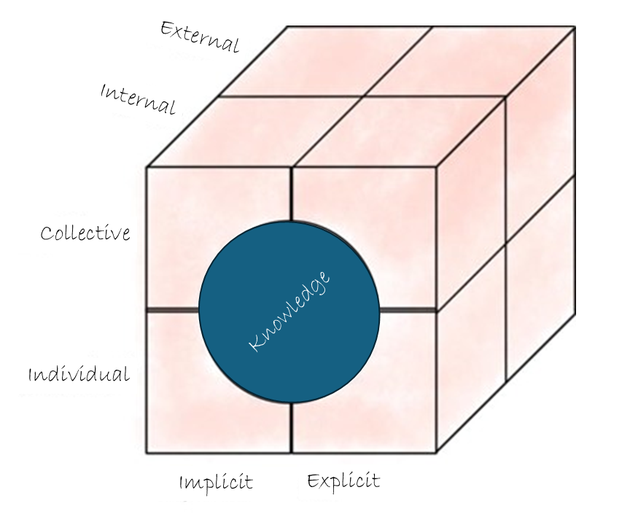

Implicit vs. explicit knowledge
Implicit knowledge is individual and personal, context-specific and difficult to put into words. The "knowledge in people's heads" comprises skills, experiences and insights that people possess intuitively.
- Implicit knowledge is like riding a bicycle - you learn it by practicing ("learning by doing") and it is difficult to describe precisely how to keep your balance in a manual, for example.
- An example of tacit knowledge in organizations is the know-how of an experienced employee who can adjust and operate a mechanical machine tool - such experiences are learned naturally in daily work.
- Implicit knowledge is passed on and shared in direct exchanges between people, in dialog or by observing actions.
Explicit knowledge, on the other hand, is formalized, systematic and easy to share and disseminate. It can be recorded in documents, manuals or databases and used by others.
- Explicit knowledge is like a recipe in a cookbook - it is clearly formulated, and the clear instructions can be easily followed by others.
- Examples of explicit knowledge in organizations are a company manual that clearly describes the procedures and guidelines to be followed, or a best practice collection that summarizes effective working methods in a document.
Some sources also refer to Tacit Knowledge as something different from Implicit and Explicit Knowledge. For example: https://bloomfire.com/blog/implicit-tacit-explicit-knowledge/ For simplicity, we have group tacit and implicit knowledge together here, but feel free to explore these concepts more on your own.
Individual vs. collective knowledge
Individual knowledge is tied to individuals. It is subjective, based on personal experience and, above all, implicit - i.e. not visible to others or easy to share.

Collective knowledge, on the other hand, is the entire knowledge of an organization. It is created when the knowledge of individuals in the organization is shared, combined and institutionalized.

Knowledge management as a discipline is concerned with the development and maintenance of collective knowledge, which is important for organizations for several reasons:
- Knowledge retention: Individual, implicit knowledge becomes explicit knowledge through documentation, for example, and is retained even when employees leave the organization.
- Increased efficiency: Collective knowledge enables new and existing employees to draw on existing experience and resources, which saves time and avoids errors.
- Innovation: New ideas and improvements can arise from the exchange of individual knowledge.
- Decision-making: Collective knowledge provides a broader knowledge base for decisions and can thus lead to more well-founded and balanced results.

The knowledge spiral (SECI model) by Nonaka and Takeuchi (1995)
The SECI model by Japanese scientists Nonaka and Takeuchi, also known as the knowledge spiral, is a dynamic model for knowledge transfer and knowledge creation in organizations that describes the transition from individual to collective knowledge and the conversion from tacit to explicit knowledge and vice versa as a continuous transformation process.

The abbreviation SECI stands for the 4 phases of this cyclical process:
- Socialization (from implicit to tacit knowledge): In this phase, knowledge is transferred through direct exchange of experience and observation - this can also happen without formal language.
- Externalization (from tacit to explicit knowledge): This is where tacit knowledge is articulated and transformed into explicit forms such as documents or spoken words. This step of documentation and processing creates new knowledge.
- Combination (from explicit to explicit knowledge): In this phase, explicit knowledge from different sources is brought together, organized and systematized to form more comprehensive knowledge repositories.
- Internalization (from explicit to tacit knowledge): Finally, the collected explicit knowledge is made accessible to employees and internalized through application and practice, thus transforming it into (new) tacit knowledge, making it part of the individual knowledge base.

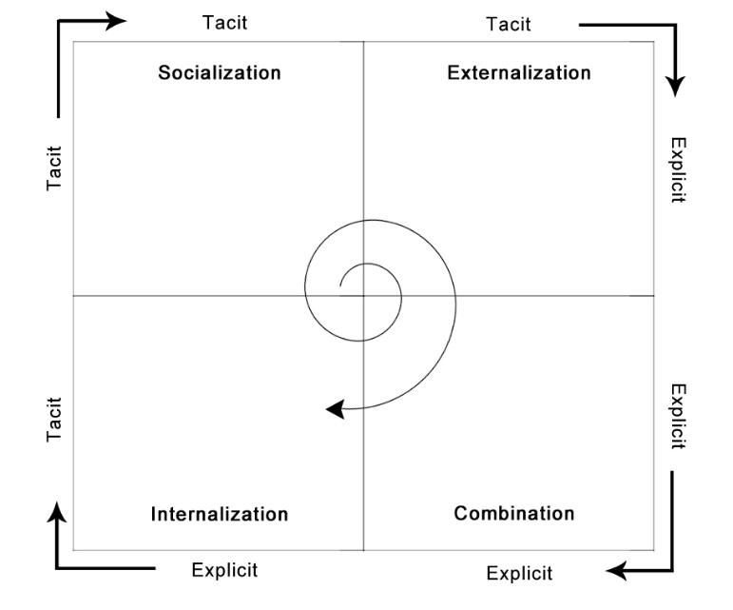
Graphic: SECI model of knowledge dimensions
(source: https://en.wikipedia.org/wiki/SECI_model_of_knowledge_dimensions)

Sources:
- Nonaka, I., & Takeuchi, H. (1995). The Knowledge-Creating Company: How Japanese Companies Create the Dynamics of Innovation. Oxford University Press.
- https://en.wikipedia.org/wiki/SECI_model_of_knowledge_dimensions
- SECI model: The knowledge spiral according to Nonaka and Takeuchi: https://blog.hubspot.de/service/seci-modell [GERMAN]
- DIN SPEC 91443:2021 Systematic knowledge management for SMEs - Tools and procedures
https://www.dgq.de/fachbeitraege/din-iso-304012021-wissensmanagementsysteme-eine-einfuehrung/ [GERMAN]

Knowledge - Formats
Knowledge can be communicated and shared with others in very different ways: we talk to other people, read a blog or comment on a video on an online platform. The formats can be described according to the following criteria:

- Conversation: personal exchange / telephone or video conference / training
  - High interaction / synchronous in real time
  - No scalability - only the participants
  - Implicit knowledge - is generally not documented
(audio and video recordings are possible in principle, especially with online formats)

- Handwritten notes: pad and pen, sticky note, flipchart, sketch note
  - Medium interaction with synchronous activity, e.g. on flipcharts
Low interaction asynchronous (for notes and transcripts)
  - Explicit, but ad hoc documentation often hardly usable without implicit context
  - Low scalability - use only possible in small groups

- Electronic document / file: Office files, e-mail, digital notebooks, mind maps
  - High scalability - can be divided and duplicated as required
  - Asynchronous / low to medium interaction (degree of interaction and synchronicity increase due to the possibilities for joint editing of documents)
  - Explicit - documentation for the purpose of passing on information and knowledge

- Online contributions (blog, communities, forums, wiki)
  - In principle, contributions on online platforms can be regarded as a subset of electronic documents:
  - High scalability / explicit
  - Higher interaction as a concrete goal of contributions - is aimed at, for example, through direct address and questions
  - Asynchronous as normal

- Lists (link collections, curated lists)
  - Scalable / asynchronous - special case of electronic documents
  - Explicit - expert knowledge flows into the selection and evaluation of the linked sources
  - Low level of interaction - primarily intended for readers as an introduction to knowledge topics / comments as suggestions for additions or corrections

The recording of synchronous events such as conversations or analog formats such as handwritten notes is primarily used for scalability and asynchronous usability, because the media can be shared via digital channels or consumed by others who were not there live:
- Images - screenshot, photo of flipcharts, graphic
- Video - recording of live discussions and presentations / screencast with PowerPoint
- Audio - Podcast, Recording with the smartphone

Knowledge staircase
Prof. Klaus North's knowledge staircase clearly explains how data, information and knowledge, and ultimately ability, action and competence are interrelated and build on each other. It relates this to a model for operational knowledge management – quasi- bottom-up starting from the management of data and information - and strategic knowledge management, which takes a quasi- top-down view starting from competence and thus competitiveness as its goal.
Find out more here:
https://wissensmanagement.open-academy.com/category/grundlagen/wissensmanagement-modelle/wissenstreppe [GERMAN]
https://www.researchgate.net/figure/Steps-of-Knowledge-Development-extended-after-Wissenstreppe-North-1998-12_fig1_49588463
In this video, Dr. Angelika Mittelmann explains the knowledge staircase using a "real" model: The knowledge staircase [GERMAN]
Prof. Klaus North’s English-language website: http://north-online.de/en/index.html
A summary of the steps of the knowledge staircase in English:
Prof. Klaus North’s Knowledge Staircase is a model that illustrates the progression from data to wisdom. Here are the key steps:
- Data: Raw facts and figures without context.
- Information: Data that is processed and organized to have meaning.
- Knowledge: Information that is understood and applied.
- Competence: The ability to use knowledge effectively in various situations.
- Capability: The capacity to perform tasks and solve problems using competence.
- Competitive Advantage: The strategic use of capabilities to outperform competitors.
- Sustainable Success: Long-term achievement and growth through continuous learning and adaptation.
This model emphasizes the importance of transforming raw data into actionable insights and ultimately achieving sustainable success through continuous improvement and learning.

The knowledge management model according to Probst, Raub and Romhardt (1999)
Probst et al. have developed a systematic approach to managing knowledge in organizations, which comprises six core processes that build on each other and work together to ensure the effective handling of knowledge.
The model has been widely accepted and disseminated because it offers a clearly structured and holistic approach. It covers all relevant aspects of knowledge management while being flexible enough to be applied in different organizational contexts. In addition, the model emphasizes the integration of knowledge processes into daily workflows and the strategic alignment of knowledge management with organizational goals, which increases its practical relevance and applicability.

Knowledge identification:
This process deals with the identification and evaluation of existing knowledge in an organization: What types of knowledge are available? Where is it located and how can it be used? Knowledge identification helps to identify knowledge gaps and understand what knowledge is particularly valuable to the organization. Methods such as knowledge maps and competence matrices are often used to support this process.
Knowledge acquisition:
Once knowledge gaps have been identified, knowledge acquisition aims to acquire this missing knowledge from external sources. This can be done through training, recruitment of experts, cooperation with other companies or research institutions and by adding new sources of knowledge such as specialist literature or databases. The acquisition of knowledge ensures that the organization has access to the necessary information and skills to achieve its goals.
Knowledge development:
In contrast to acquisition, this process focuses on the creation of new knowledge within the organization. Innovation projects, research and development departments as well as learning and training programs play a central role here. Knowledge development is crucial in order to increase competitiveness and promote continuous improvement. Formats for the exchange of experience such as communities of practice or models such as the SECI model (see above) support internal knowledge development.
Knowledge distribution:
Once knowledge has been identified and made available, it is important to distribute this knowledge throughout the organization. Knowledge distribution ensures that all relevant employees have access to the knowledge they need for their work. Various communication channels are used here, such as the intranet, knowledge databases, training courses and informal networks. Effective knowledge distribution prevents the emergence of knowledge silos and promotes exchange and collaboration
Knowledge utilization:
This process refers to the effective application of available knowledge. It is about employees using knowledge in their daily work in order to perform their tasks more efficiently and make better decisions. Knowledge utilization is promoted by a supportive corporate culture and appropriate incentive systems. It is important that knowledge is not only available, but also actively used in order to achieve the greatest possible benefit for the organization.
Knowledge retention:
Finally, knowledge retention involves preserving and safeguarding knowledge so that it remains available in the future. This is particularly important in situations where experienced employees leave the organization or when it comes to documenting valuable information from projects and processes. Techniques such as knowledge databases, documentation systems and systematic archiving play a central role in knowledge retention.
Sources:
- Probst, G., Raub, S., & Romhardt, K. (1999). Wissen managen: Wie Unternehmen ihre wertvollste Ressource optimal nutzen. Gabler Verlag.

Give feedback
Feedback can be neutral, positive (praise) and negative (criticism).

The aim should always be to formulate feedback in a concrete, factual, respectful and constructive way. Emotionality can also be used as reinforcement, especially in positive feedback. A "I think that's great" will certainly make the other person happy. But be careful - a "That's total nonsense", on the other hand, can lead to the person addressed withdrawing and no longer wanting to share their information (and other people reading along can also be put off).

In the corporate environment, it is often easiest to give feedback on shared knowledge via digital channels (e.g. reply via email or chat) and thus also show your gratitude. Of course, you can also address the colleagues who have shared their knowledge personally - but by responding publicly, e.g. in communities or ESN, you support the public direct exchange and motivate others to respond and ultimately to take the courage to share their knowledge themselves. Further advantages:
Public "liking" offers the opportunity to achieve maximum impact with minimum effort
:
- An opinion or statement whose time has come... quickly becomes
visible through x-fold likes
- A like from a person with a large network can potentially have "any" amount of impact. For example, if a manager specifically likes a topic, more employees may become aware of it.
- A survey to 1000 employees involves a lot of effort, both in terms of preparation and in terms of answering and returning the survey. A post in a large chat community can quickly reach 1000 responses and can be captured by anyone in just a few seconds.

Sources:
https://harald-schirmer.de/2019/04/07/likes-sind-mehr-als-wertschaetzung/
https://www.honestly.de/blog/konstruktives-feedback-10-goldene-regeln/

Becoming visible - "Working out Loud" (WOL)
The term "working out loud" was coined by Bryce Williams and John Stepper in 2010. The idea behind it: Making your own knowledge and work visible so that everyone can benefit from it. It is therefore about a change in mindset and about appreciative and transparent collaboration across departmental, national and company boundaries.

Numerous free instructions and tasks ("Circle Guides") have been created in the context of Working out loud.

The 5 principles behind Working out Loud
Relationships
Building a social network creates relationships that are helpful for both sides, professionally and privately. These relationships are consistently cultivated and expanded.
Generosity
True generosity expects nothing in return. According to this principle, knowledge and information is shared, feedback is offered and valuable tips are provided. In practice, this can also take the form of concrete support for projects, for example.
Visible Work
This means making your work visible, showing what you are currently working on and what interim results have already been achieved. Others can benefit from these findings, duplication of work and errors are avoided because you can build on the experience of others.
Purposeful discovery
Everyone pursues their own individual learning goal and bases their activities on this. But even outside the Circle, it is important to work on goals in a focused and disciplined manner.
A Growth Mindset
On the one hand, the feedback and expertise of others helps you to continuously improve. On the other hand, you learn to appreciate the views of others, to leave or expand your own comfort zone and to see change as an opportunity. People with a growth mindset are curious about and open to everything that the world of work and life have to offer.

Sources: https://www.projektmagazin.de/artikel/working-out-loud-bessere-zusammenarbeit, https://www.workingoutloud.com/

As part of lernOS, the topics from Working Out Loud are covered in the "lernOS for you" guide in the Openness & Networking learning path.

If you want to know more about these topics:
Overview - lernOS for you guide (cogneon.github.io) [GERMAN]

https://en.wikipedia.org/wiki/Knowledge_management
https://vonneuem.de/wissensmanagement-die-moderne-art-des-wissenstransfers/ [GERMAN]

https://qaspire.com/5-elements-of-working-out-loud-by-johnstepper/
https://de.wikipedia.org/wiki/Working_out_loud [GERMAN]
https://wol.wiki/en/start

Appendix

Templates
You can find the templates mentioned in the guide under:
https://github.com/cogneon/lernos-digitale-zusammenarbeit/tree/master/en/Templates

Making of and acknowledgements

Making of
This #lernOS guide for "Digital Collaboration" was created in a small working group as part of the Community for Guide and Multiplier Networks - using digital collaboration, of course 😉

Acknowledgments
We thank the #lernOS community for the exchange and inspiration in writing #lernOS guides, - especially Simon Dückert for the framework of the #lernOS concept.
A big thank you also goes to the Community for Guide and Multiplier Network for the open exchange and the framework for the creation of this guide!
We would like to thank everyone who tested the guide as individuals and in companies during the pilot phase and gave us feedback for improvement!
The guide was written by:
- Britta Müller-Ruhnau
- Daniel Prial
- Fabienne Theis
- Magnus Rode
- Rainer Bartl
- Stefanie Ammler

We would like to thank the following for their cooperation and support:
- Bernd Aures
- Hans-Jürgen Sturm
- Leonid Lezner

Special thanks for the great sketch notes:
- Tobias Grewe

Contact us
Do you have any questions, comments, suggestions, criticism or remarks?
Please get in touch with:
- Britta Müller-Ruhnau
- Daniel Prial
- Magnus Rode
- Rainer Bartl

Keep calm & learn on!

